Course Project - Social Media Plan

Shaun Pritchard

Rasmussen College

PSY3738

Maria Karabekou

October 14, 2020

**Course Project - Social Media Plan**

Web Reactor Tech Solutions LLC is a unique start-up tech company that I started back in 2015 in Tampa Bay. Previously called Frontside Evolution LLC (due to the nature of doing front-end web development). When I initially started the company in 2015 I tried taking on too many roles by providing too many products and services at once by myself.

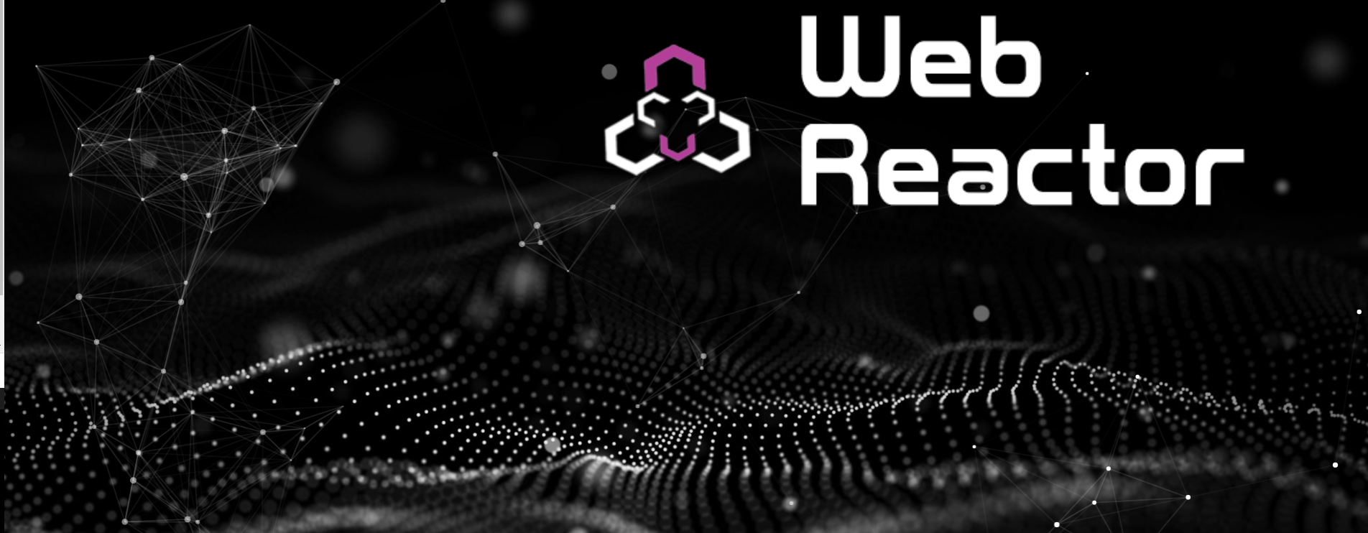

Even though I have the skill sets to facilitate doing these tasks professionally. Trying to manage too many projects became very overwhelming. When I first started, I was simply building websites for companies. While managing SEO (Search Engine Optimization) for other companies.

Then I had a great idea to do both of them at the same time because I mapped out a proprietary systems and processes that worked. Even with these systems and processes it was too overwhelming. By trade I am what regarded as a full-stack developer. Which is a web developer engineer who works with both the front and back end technologies of a website or application—meaning I can tackle projects that involve databases, building user-facing websites, or even work with clients during the planning phase of projects.

I am also an SEO expert, I have worked with 82 businesses across the country to optimize their website strategy and design *(WebReactor.us, 2020).* I have been doing SEO and web development independently for 15 years. Just managing one project to take anywhere from 6 to 12 months to complete per client.

There was a point where I had 26 clients back in 2016. I ended up hiring four Developer contractors who still work on projects with me today. Even with this help, it was still too overwhelming. I was trying to utilize all my skill sets at the same time trying to master too many things at once.

The major setback was managing these projects; project management became a very big issue. Because the time it takes this to manage one project and scope it out correctly barely leaves any time in the day to develop and design the projects.

This is what I decided to go back to the drawing board to redesign the entire business model. I had chosen to define my passion and work to model it accordingly to fit my business. My overall passion is to create. I love to program and write code, but I love to design video and graphics. I also like helping businesses to grow, helping them to strategize, and helping them become successful.

I have already built a really good reputation in Tampa as one of the leading #1 SEO developers. Helping businesses reach the top search engines driving more traffic to their businesses and websites gaining more leads. Because of this, I did not want to abandon my former clients. Nor did I want to abandon the skills and knowledge that I had implemented and acquired.

I have now simplified the business model and I am still currently building out my new vision while maintaining my clients, going to college full time, and dealing with my disabilities from being in military service.

**Application development:**

* **Front-end development** - this is the development of the initial design and graphics of a website or application. The looks and appeal
* **Back End development** - Is the abstract coding and logic that connects a website to a database and involves working website data.

**SEO (Search Engine Optimization):**

* **SEO** - is the optimizing of a website through, design, metadata, keywords, content, and marketing strategy. There are over 200 factors and tasks to be completed to meet the criteria of ranking first position in the search engineer.

**Important info about SEO**

Is important to know there are billions of websites out there (Internetlivestats.com, 2020). A lot of businesses, entrepreneurs, and companies who start a new business or have been in business know they need a website. Most people do not understand that a website is more than just a presence on the web to offer your phone number or contact(digital business card). Websites and applications are dynamic tools that are capable of automating work and producing, allocating, and delivering data.

Search engines today have created massive online economic markets. Those businesses who show up at the top search results are the ones who get 33% of the traffic Organic Listings receive 90% of traffic *(smartinsights.com, 2020).* That traffic is in turn yields clicks that can be translated into prospect leads and new customers. Simply throwing a website out on the web no matter how good it looks will not ensure that position. If a website is not optimized correctly it will never see the top of the search engine *(www.protofuse.com, 2014).*

**Video Production:**

There are many factors involved in this optimization process. One of the main factors is the content. Video content is the highest converting content there is online today. Many businesses today are moving to create more video contests through channels and on their websites to drive more traffic, but they do not have the resources or knowledge of how to create engaging content, video openers, brand openers and closing, content production, VFX, editing, and color correction. Let alone understand how to manage platforms that facilitate driving results.

**Consulting Services:**

Helping businesses and clients plan, scope and get their projects going to be developed. The initial planning phase of an application projects and scoping out all of the resources needed to complete that project including the time it will take.

**My Vision - Solutions and goals:**

Web Reactor simplified would allow me to reach my ultimate goals while allowing me to utilize the skill sets that I am most passionate about to build a successful business.

My ultimate goal is to scale to a point or I can develop a full team of developers, designers, and other resources that will allow me to facilitate building out major projects that I'm personally working on now. while still providing niche solutions and new market products I have already developed for Web Reactor.

My passion is in design and creation, but my real passions lie within the research development section of my company. For two years I have been developing and designing two different applications and another IoT device that I am currently working on. Here are the applications I have been working on.

**My Future Vision - Proprietary apps and inventions:**

*(Apps I am currently building)*

* **DriveGaurd**- is a proprietary application that connects to smart devices, but I personally like engineering that will stop texting and driving. The device that can detect where a user's phone was during an accident. While also acting as a kill switch in only the driver seat of a vehicle while unaffecting all other passengers' seats and areas and disabling mobile devices behind the wheel. The application can be used to automatically detect and turn off messaging and social media apps while the car is in motion.
* **Universe.IO**  - is an augmented reality social media application that works like Facebook except it allows people to upload any type of digital content images and videos to the world through The Eyes of augmented reality. Imagine looking through your phone I'm pulling up to a business to see some funny message or an advertisement for an opposing company. Imagine leaving a bread Trail of love notes for somebody you love to follow. Then imagine that on a social level with everybody who is connected to you.

These are applications that I am building in my business. They do not pertain to my business model directly. I would like my business to be able to grow to where I can start putting these ideas into full production. Until then I will slowly chip away at them. Notifications are developed. The drive guard is fully developed. I am just working on the mobile app and will be seeking investors next year. I also plan on presenting this to the Pasco County Sheriff in February 2021.

Universe.IO is only the third phase I am currently working on how to share and track the data in augmented reality between users using graph algorithms. At this point, people can sign up for it and go into an account. There are still many features that need to be added. Also, I have to finish modeling the database. I am hoping this product will be ready in about 2 years. That is unless I can get help and I am a team.

**My Vision - Current Business Model:**

I had to reassess a lot of things with my old business model and I had to cut out a lot of the things I was doing. I have simplified development and design through processes and systems that I have created including applications that I have built for users.

I am no longer offering private SEO services except for a few select clients. I developed what I called the SEO Task application. This is an application any business owner entrepreneur with a website can download and start following the exact steps that I would take to optimize their website.

This product in itself frees up time allowing me to offer tiered web application or site development services. Allowing the business owner to take control of their SEO while I manage it. The SEO Task App is an application that has all the steps with everything that a client would need to know to optimize their website with full video instruction.

This product also allows me to only offer tiered web development services, hosting, and site management. While opening up new doors for me to specifically focus on video production and design services.

 I also have pre-built cross-platform applications that I can customize for any business use. These applications can be used on any device and can be designed fairly quickly depending on the complexity and abstraction. So far, I have only been building these applications for churches. Other small Services I offer only correlate to the main services and products. Such as google local SEO services, and social media channel setup.

 I have written several product books that give the exact instructions on how to set up your social media account whether it is Facebook or YouTube correctly so that way it is optimized. Other than that, my only other service is consulting. I have stepped away from major projects and only offer service to help companies and individuals to scope out the full design of the software applications they want so one of my partner companies or associates can build it.

This frees up a lot of time for me allows me to focus on specific design work, the occasional service, and building my applications. My products sell themselves once clients purchase them. Ultimately, I will phase out the design work that I am doing to facilitate only selling my product applications I am building my platforms. Also, I have a companion eLearning site called Dev Reactor that facilitates live streams lessons explainers and video-based learning resources.

So, in essence this is kind of a 3-phase business model which I have completely scoped out to grow in a specific direction. I did this by building products that do the work for me and my clients. If you compared me to a magician, it would be the equivalent of him/her building an application that gives away all the trade secret tricks. All of the acquired knowledge and Inside information that I learned working with other tech companies are professionals. This allows me to do what I want to while following my passions. Although I do imagine other SEO's are not too happy about it?

**Web Reactor:**

URL: <https://webreactor.us/>

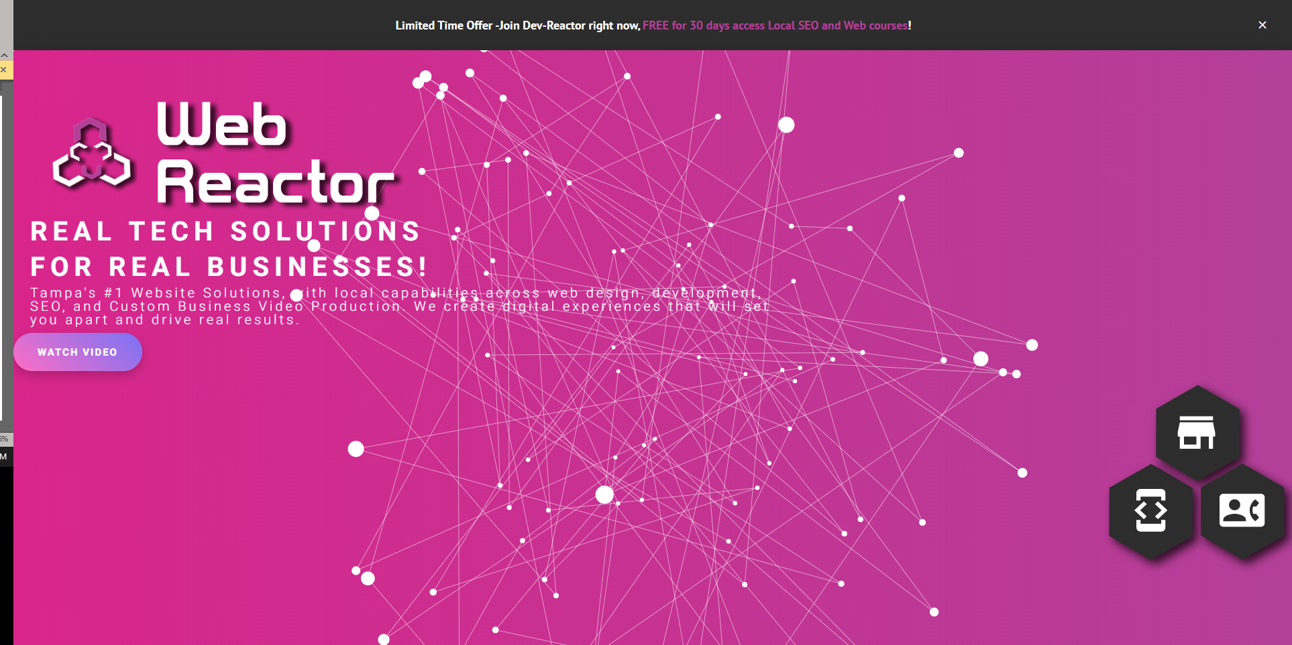

**Dev Reactor:**

URL: <https://devreactor.pro/>

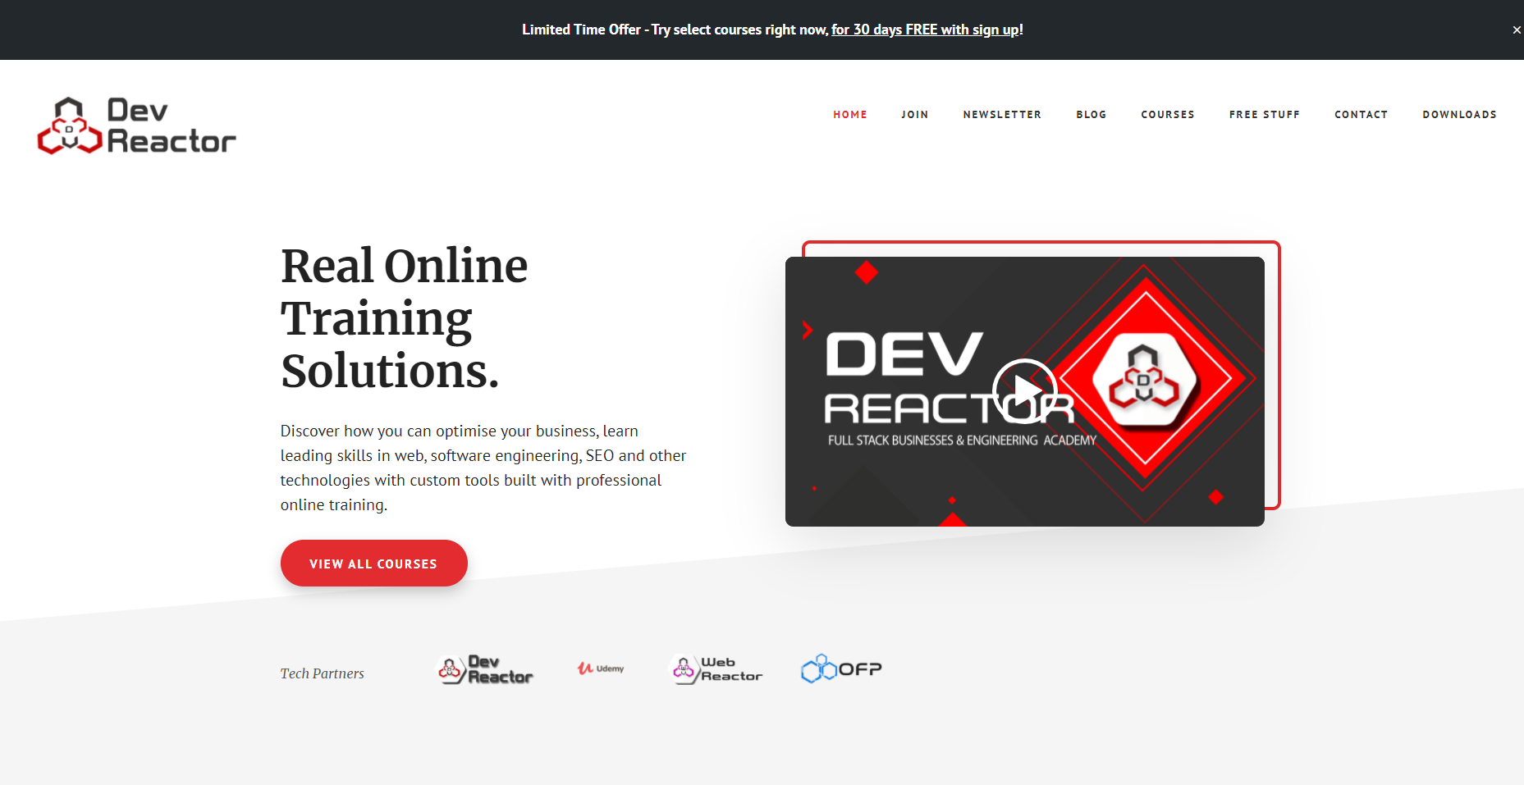

***Current Business Model***

*This is the simplified new business model I am currently building. Relating to the main two categories of* ***services*** *and* ***products****.*

**Web Reactor Products:**

* **SEO Task App:**

A full licensed version of the "SEO Task App". A full in-house developed application to track the workflow, project, metrics, visualizations, and automate and optimize the entire website/application SEO project.

The SEO task app comes with a full step by step video instruction library with lessons of our industry-standard SEO practices and full lifetime membership. DevReactor.pro website. It offers full tools and resources for every step of the search engine optimization process and full instructions to launch and track content and digital marketing plan needed to reach the top of the search engine results.

The SEO Task App is SEO in a box built for the average non-technical business owner. All they need is a functional website and access to the SEO task Application and E-learning videos to guide. The SEO Task App is built to use with full internal teams, DYI, or they can pay us to implement SEO solutions that are proven to drive results and top search engine ranking positions.

* **SEO ready Web Applications:**

We offer 3 types of Business websites Each website gives access to the SEO Task App and access to the video library.

* + **SEO Starter Basic** - Full SEO ready 5-page website with custom graphic design and access to SEO Task APP.
  + **SEO Pro -** Everything with SEO starter Basic including, keyword planning, Google Local SEO, listings, and keyword plan, Full audit, and SEO Task App data.
  + **SEO Elite** - Everything with SEO Pro including Google SEO product keywords, Business directory listings, Keyword list, pages speed optimization, and much more.

*E-commerce integration cost for any website starts at 100.00 per product price reduction based on the number of products:*

* **Graphic Design**

Graphic design products are digital design products that can be used for any medium or digital application.

* Brand logo creation
* Web Design
* 3D Web design
* Custom Graphics
* **Video Production**

In today's world, Video content is certainly king, and bad videos don't get seen! We create full-production video and graphics, animation, commercials, openers, Video explainers, music videos, music openers, closeouts, editing, color correction, VFX, and jaw-dropping video that converts and people want to engage.

* **E-Learning:**

With the tools I provide such as the SEO task application and other applications and services. I create video tutorials, E-lessons, and content instructional videos to help use my products. I have a sister e-learning platform called Dev reactor at www.devreactor.pro. I facilitate a membership-based site for users who want to use my content to learn or use it to use the tools I have created.

**Web Reactor Services:**

* **Social Media Services:**

Allows me to design, manage, and guide your social media channels the correct way. I offer graphics, design, setup services to ensure user engagement. I have digital video products to give step-by-step instructions on how you should be setting up your social media site, what keywords to use much more. Setting up your social media site can mean the difference between non-existents and engagement for your brand.

* YouTube
* Facebook
* Instagram
* Twitter
* SteemIt
* Tik-Tok
* Snapchat
* **Consulting Services:**

I have our major projects that were working on the way I'd love to help you get yours out to the world. Scoping out any software application is a very major task and you find it out correctly any vital to his success. That is why we offer full affordable Consulting Services.

* + Software engineering
  + Web Applications
  + PWA
  + IoT (Full circle from cloud to device implementations)
  + Desktop Applications
  + SPA
  + Agile

**Competitor Research:**

**My Companies(based in Tampa Bay):**

* Web Reactor - graphics, web design, SEO tools, video production: [https://webreactor.us/](https://webreactor.us/%20)
* Dev-reactor - educational website to learn SEO, marketing, and other technical skills: <https://devreactor.pro/>

**Web Graphic design companies:**

* InCube: <https://designer.incube.agency/>
* Studio Center: [https://studiocenter.com/](https://studiocenter.com/%20)
* Simple Machine Designs: <https://simplemachinedesigns.com/>

**Video Production /AR:**

* GravityJack: <https://gravityjack.com/>
* Ykob: <https://ykob.github.io/sketch-threejs>
* captivation: [https://www.captivation.agency/](https://www.captivation.agency/%20)

Web design has potential is reported high for this type of business since costs are relatively low. A one-person web development company can clear $65,000 per year. If you have a team of developers, the profit potential is much higher. For example, a 5-person company could clear $400,000 to over $1 million in revenue, depending on average project size and hourly rate *(Truic, 2020).*

Video production is also a growing industry the growth of video production over the last years has been increasing substantially from 2014 to 2018 and it has almost doubled in annual revenue to 286 billion. It is predicted that the market will grow during the next decade as online video consumption keeps increasing and video marketing has become the most effective way to communicate with customers *(Millennial Studios, 2020).*

I would like to note that using for social media choices for your branding is something that has to be established over time typically it is best practice to grow one social media channel and then Branch out once you growing a following. But here are my selections for the four social media choices I would use for marketing and brand exposure.

**Social Media Channels Opportunities:**

* **YouTube:** YouTube provides a platform for video content creation. this exposure can elicit a major response depending on the scope of the channel. a major percent of the content on YouTube is information is self-serving information. Meaning people typically record themselves doing what they like and do not provide any value unless they are providing entertainment. This leaves a major opportunity to create contact. Can learn from them and that brings them actual value. And as mentioned before this creates a perfect opportunity to monetize and grow your channel and business (Gary Vaynerchuck, 2018).
* **Facebook:** Facebook is one of the oldest platforms around and facilitates the use of business pages and is now Incorporated into a YouTube-like video program that allows creators with a certain amount of followers to monetize on the content they put into the system as well. Facebook can run ads and engagement with many individuals for a very low-cost so it's really easy to get your message to the masses using Facebook and even send them back to another social media channel (Gary Vaynerchuck, 2018).
* **Instagram:** Instagram is a social media site that is basically for imagery cannot post videos like you can on YouTube. you are limited to short 1-minute videos that are
* used for social status. Even in business you should have a social status and upload daily or weekly images and clips to this platform can help you build followers depending on your niche. Facebook also owns Instagram and the technologies are inner linked meaning Facebook posts can be published to Instagram and vice versa (Gary Vaynerchuck, 2018).
* **SteemIt:** Steemit is a very cool website in that it is a crypto-currency based website which is called Steam. The interactions of cryptocurrency provide value to Publishers of content on the platform and that's the most popular post get paid out and steam coins which can be translated into US dollars therefore simply posting normal activity or can do you want any other platform except you to get paid for it on Steemit. Depending on legend topic you can earn as little as a few pennies to a few hundred dollars and even more (Gary Vaynerchuck, 2018).

**My Social Media Channels:**

Below are the current social media sites that I am implementing for my business. Each site has a specific reasoning and plays into driving traffic, engagement, building more clients and resources. I use each Channel in coordination with each other and my content plan.

**YouTube:**

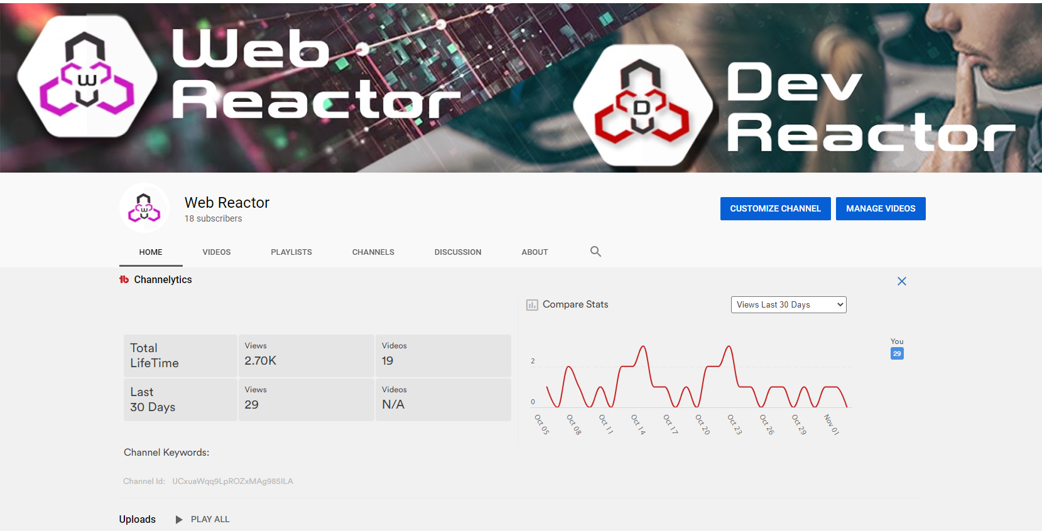

YouTube is a great channel to start building an audience. Even though I sell digital products, one of my digital products the SEO task app requires video e-learning course tutorials and video contest to supplement and use the application. Not only does you to provide me a channel that will allow me to host of video content to my applications, but it can host Conte related to my applications and relayed it to my industry.

I use YouTube to put out weekly videos on SEO, fact-checking, website Technologies and product reviews. It also allows me a forum to discuss my ideas and opinions about technology and how to implement it with best practices for business.

Also, I can advertise on YouTube not only in my channel but I can use Google analytics platform to pay replacement in video ads convert my digital products and services for Web Reactor and Dev Reactor my e-learning site. YouTube is the heart and soul of my operation because I put out content weekly. I have a strong bass that depends on the videos that I put out.

They count on me to consistently put out videos and information that helps them with their business or with the tools that I provided them. I also do tutorial classes on programming code and many other things that business owners people trying to become software developers get interested in as well. My main goal for the channel is to Simply build rapport and put out consistent videos and content. Overall, this says is help me to establish my base and my brand.

**Facebook:**

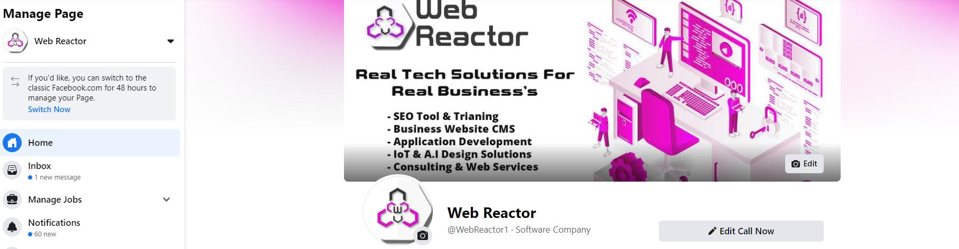

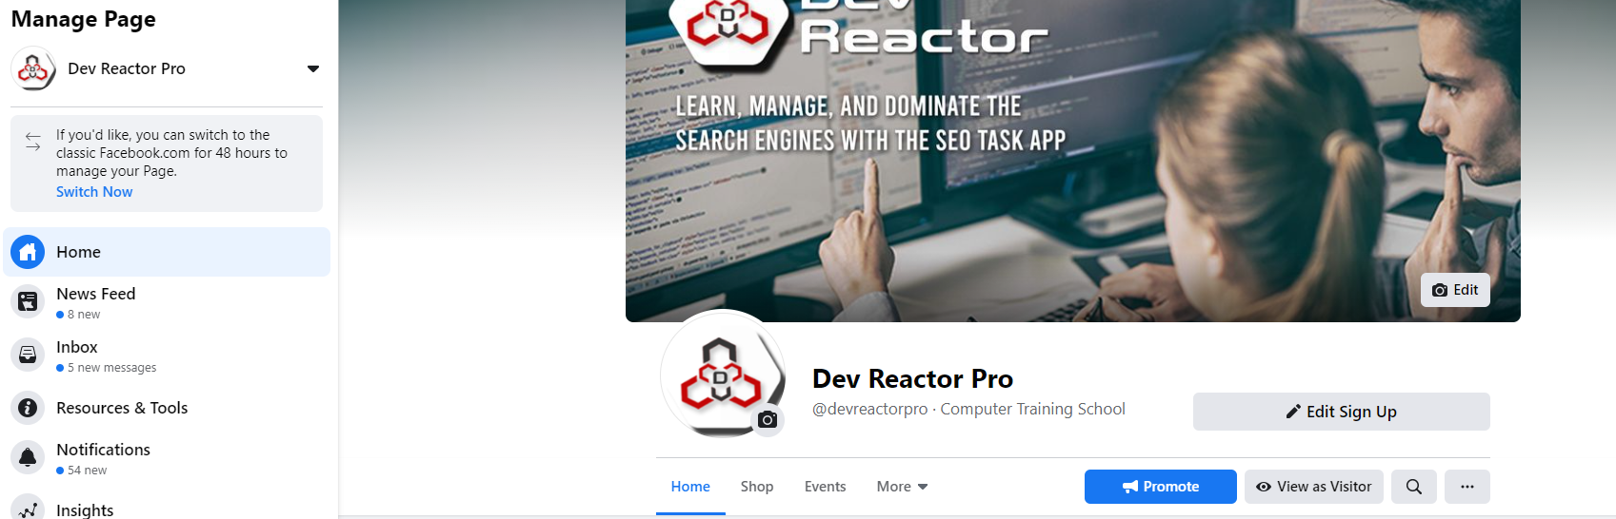

I use two Facebook pages for my business one pages to promote my actual business products and services while the other page is to manage my students and my video content. Facebook is really great resource because it allows me to have outreach to not only local businesses but to advertise to businesses based off of inherent associations, behaviors, and interest.

Also, allows me access to platform to update and engage with an audience on a daily basis to retain clients and to build my brand. Building a brand is very important because your brand is basically your reputation. This allows me a platform to build that reputation Plus procure more clientele. It also helps me to recruit potential Talent as well. It also provides a platform to host and sell my products as well.

My goal for Facebook is to use it as a platform for advertising when my products are finished if I have new releases a my audience is small business owners, entrepreneurs, software Developers and people of the tech industry. Typically, I use Facebook ads still the specific audience. My products or services and I use an allocated budget to put my message in front of potentially hundreds of thousands of people in which then I receive return on my investment.

**Instagram:**

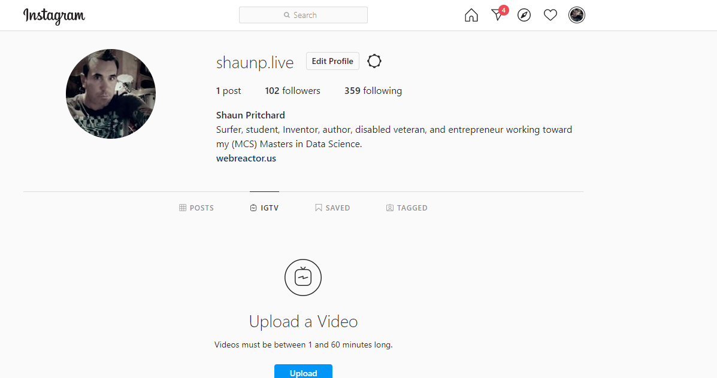

Instagram is a really good basis to meet you clients, but it's a really good way to build your brand in the sense that you can connect with all kinds of people who find your basic activities appealing every day.

I try to post to Instagram everyday typically pictures of what's going on, but this keeps people engaged. Also, a picture of, business updates, technology or applications that I'm working on and it's kind of like a Daily Journal for the business but with pictures and videos in the sense that I can use it to advertise on and build my popularity on.

Also, I can connect applications in autumn my website to Instagram. I can also load videos on Instagram, but I use Facebook to load my videos and then forward my videos into Instagram from Facebook. Essentially my goal with Instagram is to stay engaged and reach new faces of clientele. My audience on this platform would be more geared towards businesses and business owners. But there are a lot of entrepreneurs and self-proclaimed business owners who do have their own personal brands and can still use my tools and resources. I hope to try to connect with more people. I find having a scheduled posting that people can rely on helps out a lot. People can count on my content and they will be very inclined to follow and engage with me.

**SteemIt:**

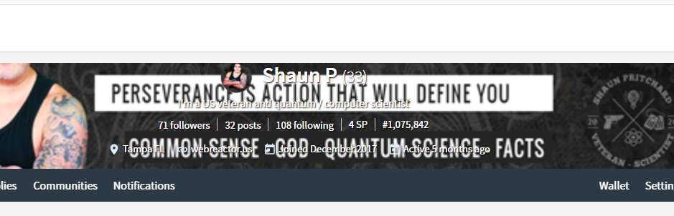

SteemIt it is just a place where I unload all my contact. Like YouTube I try to provide value in everything I do but I can upload all my business info and personal license everything that I feel I want on the web to site similarly to my website. The reason for being is that my content gets weighed and viewed and the more views I have means I can possibly get up quotes and every upload I get allows me to earn cryptocurrency that can actually translate into US dollars. I have had three post make $900.

Essentially, you get paid to put your content on this platform. Why everybody is not using it is beyond me.? Also, gives me new reach with the new possible users. My goal is to earn interest with my content and my audience is people who are in tech, programming, business, Entrepreneurs, and Developers.

# References

Gary Vaynerchuck. (2018). *Crushing it.* NewYork: HarperCollins Books.

Internetlivestats.com. (2020). *Total number of Websites*. Retrieved from https://www.internetlivestats.com: https://www.internetlivestats.com/total-number-of-websites/

Millennial Studios. (2020, Jan 20). *Video Production Industry – all you need to know (Statistics, analysis, trends)*. Retrieved from https://millennialstudios.co.uk: https://millennialstudios.co.uk/blog/video-production-industry/

smartinsights.com. (2020). *Keyword research data reveals the click-through rewards for top of SERP organic rankings*. Retrieved from https://www.smartinsights.com: https://www.smartinsights.com/search-engine-optimisation-seo/seo-analytics/comparison-of-google-clickthrough-rates-by-position/

Truic. (2020). *HOW TO START A WEB DEVELOPMENT COMPANY*. Retrieved from https://howtostartanllc.com: https://howtostartanllc.com/business-ideas/web-development

WebReactor.us. (2020). *Web Reactor*. Retrieved from https://webreactor.us/: https://webreactor.us/

www.protofuse.com. (2014, April 4). *The First Page of Google, by the Numbers*. Retrieved from www.protofuse.com: https://www.protofuse.com/blog/details/first-page-of-google-by-the-numbers/